|  |  |
| --- | --- |
| Roll No.: A016 | Name: Varun Khadayate |
| Class: B. Tech CsBs | Batch: 1 |
| Date of Experiment: 20-09-2022 | Subject: ITWS |

Lab 8

# CircleIO.m

|  |
| --- |
| % This script calculates the area of a circle  % It prompts the user for the radius  %Prompt the user for the radius and calculate the area based on that radius  fprintf('Note: the units will be inches. \n')  radius = input('Please enter the radius: ');  area = pi * (radius ^2) ;  %Print all variables in a sentence format  fprintf('For a circle with a radius of %.2f inches, \n' ,radius)  fprintf('the area is %.2f inches squared \n' , area) |

# plotonepoint.m

|  |
| --- |
| % This is a really simple plot of just one point !  % Create coordinate variables and plot a red ' *  x = 11;  y = 48;  plot(x, y, 'r*')  % Change the axes and label them  axis([9 12 35 55])  xlabel('Time')  ylabel('Temperature')  % Put a title on the plot  title('Time and Temp') |

# plot2figs.m

|  |
| --- |
| % This creates 2 different plots, in 2 different  % Figure Windows, to demonstrate some plot features  clf  x = 1:5; % Not necessary  y1 = [2 11 6 9 3] ;  y2 = [4 5 8 6 2] ;  % Put a bar chart in Figure 1  figure (1)  bar (x, y1)  % Put plots using different y values on one plot with a legend  figure (2)  plot (x, y1, 'k')  hold on  plot (x, y2, 'ko' )  grid on  legend ( 'y1' , 'y2') |

# sinncos.m

|  |
| --- |
| % takes the character and the number and prints them  a=input('Enter a character--->','s');  n=input('Enter a number--->');  % display the character in a field width of 3.  fprintf('%3c',a);  fprintf('\n')  % display the left-justified number in a field width of 8 with 3 decimal places.  fprintf('%-8.3f\n',n); |

# Practice 3.1



|  |
| --- |
| % This script calculates the circumference of a circle  % It prompts the user for the radius  %Prompt the user for the radius and calculate the area based on that radius  fprintf('Note: the units will be inches. \n')  radius = input('Please enter the radius: ');  area = 2 * pi * radius ;  %Print all variables in a sentence format  fprintf('For a circle with a radius of %.2f inches, \n' ,radius)  fprintf('the Circle is %.2f inches \n' , area) |

# Practice 3.2

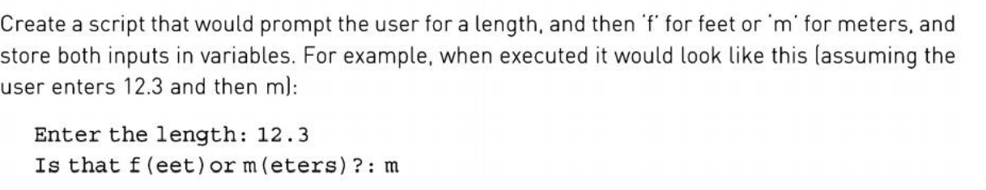

|  |
| --- |
| % This script records the length and the unit of that length  % It prompts the user for the radius  % Promts the user for values and stores them  length=input ( 'Enter the value for length: ') ;  units=input ( 'Enter the units for length (f or m) : ', 's'); |

# Practice 3.3

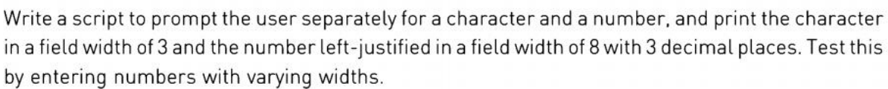

|  |
| --- |
| % takes the character and the number and prints them  a=input('Enter a character--->','s');  n=input('Enter a number--->');  % display the character in a field width of 3.  fprintf('%3c',a);  fprintf('\n')  % display the left-justified number in a field width of 8 with 3 decimal places.  fprintf('%-8.3f\n',n); |

# Practice 3.4



|  |
| --- |
| % This script plots one point (time, temp) from data  % acquired from the user.  % Ask the user for the data to plot and store in the  % variables time and temp  time = input('Enter the time in hours: ');  temp = input('Enter the temperature in degrees C: ');  plot(time,temp,"*")  % Adjust the x and y axis limits  axis([time-2 time+2 temp-3 temp+3]);  % Label the axis  xlabel("Time (hours)")  ylabel("Temperature (C)")  % Add a title  title("Time vs Temperature for Just One Point!") |

# Practice3.5



|  |
| --- |
| % creates two different plots  x=1:5;  y1=[2 11 6 9 3];  y2=[4 5 8 6 2];  %Put a bar chart in Figure 1  figure(1)  bar(x,y1)  %Change the axis settings  axis([0 6 1 12]);  %Put plots using different y values on one plot with a legend  figure(2)  plot(x,y1,"k")  hold on  plot(x,y2,'ko')  grid on  legend( 'y1', 'y2')  %Change the axis settings  axis([0 6 1 12]); |

# Practice 3.6



|  |
| --- |
| x = 0:3.5;  plot(exp(x),log(x)) |

# Practice 3.7



|  |
| --- |
| % This script asks for user input for the number of rows  % and columns for a matrix. Then a matrix of that size is  % filled with random numbers and save in ASCII format to a  % file.  % Ask user for input  row = input('Enter the number of matrix rows: ');  col = input('Enter the number of matrix columns: ');  % Create the matrix of random numbers of specified size.  mat = randi(25, row,col)  % Save the matrix as an ASCII file.  save myMatrix.dat mat -ascii |

# Practice 3.8

|  |
| --- |
| row = [1.2 1.4 1.8 1.3];  col = [2.2 2.5 1.7 2.9];  mat = [row;col]  % Save the matrix as an ASCII file.  save salesfigs.dat mat -ascii  % Load .dat file  load salesfigs.dat  x=salesfigs(1,:)  y=salesfigs(2,:)  plot(1:numel(x),x,'o')  hold on  plot(1:numel(y),y,'.','MarkerSize',20)  ylabel('Sales(billion)')  title('ABC corporation Sales:2013')  legend('Division A','Division B')  hold off |

# Practice 3.9



|  |
| --- |
| function [ V ] = conevol( r,h )  % CONEVOL finds the volume of a cone  % Format of call: conevol(r,h)  % Returns cone volume  V = pi * r^2 * h/3;  end |

# Practice 3.10

|  |
| --- |
| function [ A ] = calcrectarea( L,W )  % CALRECTAREA Finds the area of a rectangle rounded up to  % the nearest integer.  % Format of call: calRectArea(L,W)  % Returns rectangle area rounded up to the nearest integer  % Compute the area and round the result up to the nearest integer.  A = ceil( L * W );  end |